**Clean-200 Self-Cleaning Support**

**User Manual**

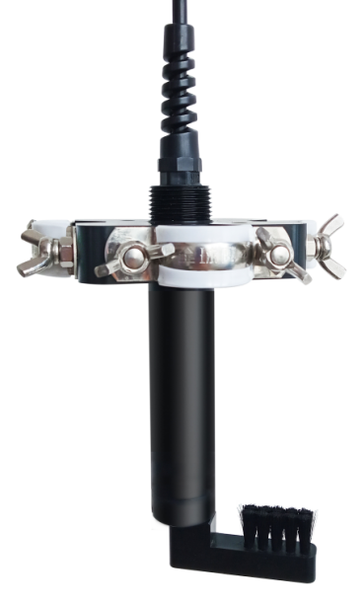

## 

## User Notes

* Please read the instruction carefully before using and save it for reference.
* Please follow the instructions and precautions.
* When receiving the instrument, please open the packaging carefully, inspect equipment’s damage level in case of transportation, if you found spoiled equipment, please immediately notify the manufacturer and distributor, and retain the packaging, in order to send back to processing.
* When the instrument is in trouble, please do not repair it by yourself, please directly contact the maintenance department of the manufacturer.
* Default cleaning revolution for positive and negative turn 3 laps, cleaning time interval for 30 minutes.
* When the sensor is installed, it is advisable for the cleaning brush to just contact the surface of the sensor measuring area. If the distance is too close, the cleaning brush will squeeze the measuring area for a long time, which will easily lead to scratches on the surface of the measuring area. If the distance is too far, the cleaning effect will be poor.

Content

1、Summary 4

2、Characteristic 4

3、Technical parameters 4

4、Dimensional drawing 4

5、Effect picture . 5

6、Cable information . 6

7、Answers to frequently asked questions 6

8、Quality assurance 6

9、 Accessories spare and parts 6

10、After-sales service commitment 6

Appendix data communication 7

## Ⅰ、Overview

Clean-200 online self - cleaning stand is reliable and easy to use. Up to four digital sensors can be installed at the same time. Parameters such as dissolved oxygen, pH, ORP, conductivity, turbidity can be selected.

The CLEAN-200 online self-cleaning bracket is equipped with an automatic cleaning device, which consists of a built-in motor drive circuit, a position detection circuit, a DC motor and a cleaning brush. The automatic cleaning device can effectively remove dirt on the surface of the sensor and prevent the attachment of microorganisms, greatly reducing the maintenance cost. The sensor can be conveniently mounted outside the cleaning bracket.

The upper end of the cleaning bracket is designed with 3/4 "NPT thread for easy mounting.

## Ⅱ、Characteristic

* Equipped with automatic cleaning device, can effectively remove the sensor surface contamination, prevent the adhesion of microbes, more worry, more low maintenance.
* Optional installation, conductivity, dissolved oxygen, turbidity, pH, ORP sensor for on-line monitoring for a long time.
* Can be installed at the same time four digital sensors, measuring five parameters.
* Customers according to actual needs, external application of the jet pipe, water spray, ultrasonic cleaning head, sodium hypochlorite generator (antifouling), etc.

## Ⅲ、Technical parameters

|  |  |
| --- | --- |
| **Clean-200 self-cleaning support** | |
| **Operating temperature** | -5~50oC |
| **Power Supply** | 12～24VDC |
| **Cable specifications** | Φ6 mm, 4core, 5 meters (customizable) |
| **Space usage** | 85mm×85mm×20mm |
| **Power Consumption** | 0.1W@12V |

## Ⅳ、Dimensional drawing

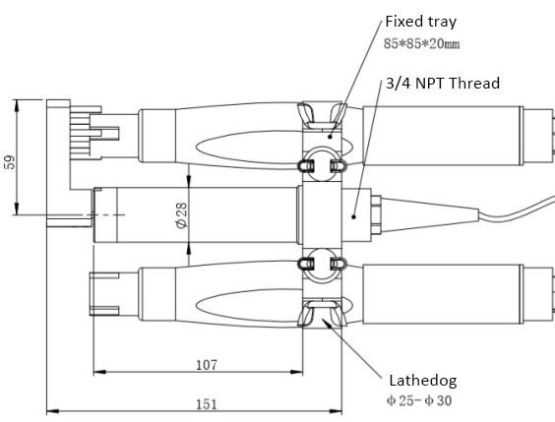

**Ⅴ、Effect picture**

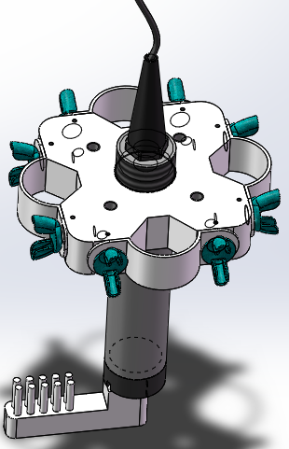

Cleaning bracket renderings

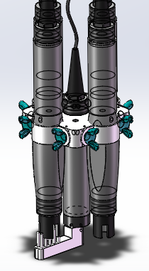

Installation sensor renderings

## Ⅵ、Cable information

4-core shielded twisted pair line, its citation is defined as:

* Red line —power cord(12V~24V DC)
* Black line—ground(GND)
* Blue line—485A
* White line—485B

Note: The blue and white lines are communication lines, which are used to set the cleaning revolution and cleaning interval time through the 485 interface. The communication protocol is Modbus protocol (see appendix). In order to prevent the blue and white lines from accidentally touching the power terminal and causing communication failure, the blue and white lines are not led out by default. If you need to change the cleaning parameters, please strip them out of the cable by yourself.

After the wiring is completed, it should be carefully checked to avoid the wrong connection before the power is turned on.

**Cable specification:** considering that the cable is immersed in water (including sea water) or exposed to air for a long time, the cable has a certain corrosion resistance. All interfaces of cable outer diameter Φ6mm, have been waterproof.

## Ⅶ、Answers to frequently asked questions

|  |  |  |
| --- | --- | --- |
| **Error** | **Possible reasons** | **Solution** |
| Cleaning brush does not turn | Motor fault | Please contact us |
| Cable fault | Please contact us |

## Ⅷ、Quality assurance

* The quality inspection department has a standard inspection procedure, with advanced and complete detection equipment and means, and according to the procedure inspection, the product is subjected to 72-hour aging experiment and stability experiment, so that a non-conforming product is not allowed to leave the factory.
* The consignee shall refund directly the product batches with a failure rate of 2%, and all expenses incurred shall be borne by the supplier. Consider the standard reference to the product description provided by the supplier.
* Ensure the quantity of goods and the speed of shipment.

## Ⅸ、Accessories and spare parts

The products include:

* With one self-cleaning support
* 1 Specification
* 1 certificate

## X、After-sales service commitment

The Company has provided the local after-sales service within one year from the date of sales, but does not include the damage caused by improper use. If it is necessary to repair or adjust it, please return it, but the freight is required to be self-contained. When it is returned, it shall be confirmed that the package is good to avoid damage during transportation. The Company will repair the damage of the instrument free of charge.

## Appendix data communication

1. **Data format**

The default data format for Modbus communication is: 9600, n, 8, 1 (baud rate 9600bps, 1 start bit, 8 data bits, no check, 1 stop bit)。

1. **Information frame format** (xx for one byte)
2. Read data instruction frame

06 03 xx xx xx xx xx xx

Address FC Register start address Number of registers CRC check code

(low bytes in front)

1. Read data response frame

06 03 xx xx……xx xx xx

Address FC Bytes Response data CRC check code(low bytes in front)

1. Write data instruction frame

06 06 xx xx xx xx xx xx

Address FC Register address read-in data CRC check code(low bytes in front)

1. Write data response frame (co-write data instruction frame)

06 06 xx xx xx xx xx xx

Address FC Register address read-in data CRC check code(low bytes before）

1. **Register address**

|  |  |  |  |  |
| --- | --- | --- | --- | --- |
| **Register address** | **Designation** | **Description** | **Number of registers（The number of bytes）** | **Access mode（Function code）** |
| 0x2002 | Device address | Default is 66, data range 1 to 127. | 1 (2 bytes) | Write(0x06)  /Read(0x03) |
| 0x1300 | Automatic cleaning interval time setting | The default is 30 minutes, and the value is set within the range of 6 to 6000 minutes. | 1 (2 bytes) | Write(0x06)  /Read(0x03) |
| 0x1301 | Automatic cleaning revolution setting | Default is positive and negative 3 turns each, the value range is 0 ~ 10. | 1 (2 bytes) | Write(0x06)  /Read(0x03) |
| 0x2020 | Reset sensor | The auto-cleaning revolution and auto-cleaning interval are restored to default values. The written data is 0. | 1 (2 bytes) | Write (0x06) |

1. **Command example**
2. Change the Device Address：

Function: Change the Modbus device address of the device.

Change device address 66 to 01. Example is as follows:

Request frame：42 06 20 02 00 01 EC F9

Response frame：42 06 20 02 00 01 EC F9

b) Change the interval time of automatic cleaning:

Change the interval of automatic cleaning to 6 minutes. Examples are as follows:

Request frame：42 06 13 00 00 06 03 BF

Response frame：42 06 13 00 00 06 03 BF

c) Change the automatic cleaning revolution:

Change the auto-cleaning revolution to 5 turns. Examples are as follows:

Request frame：42 06 13 01 00 05 12 7E

Response frame：42 06 13 01 00 05 12 7E

d）Read the auto-cleaning revolution：

Request frame：42 03 13 01 00 01 DF BD

Response frame：42 03 02 00 05 3D 88

In the response frame, 42 is the address of hexadecimal device, 03 is the function code, 02 is the number of bytes, and 00 05 is the number of revolutions of 5.

**5. Error response**

If the device does not execute the command correctly, the following format information is returned:

|  |  |  |  |  |
| --- | --- | --- | --- | --- |
| **Definition** | **Address** | **Function code** | **Code** | **CRC check** |
| Data | ADDR | COM+80H | xx | CRC 16 |
| Number of bytes | 1 | 1 | 1 | 2 |

1. CODE：01 – Functional code error

03 – Data error

1. COM：Received function code